**1. INTRODUCTION**

Natural disasters like floods and cyclones cause severe damage to life and property. Timely warnings help reduce risks, but traditional methods are often slow or ineffective. Using the MERN stack, a web-based system can provide accurate, real-time alerts and serve as a centralized platform for disaster information.

**1.1 PURPOSE**

The purpose of this document is to design and develop an **online Flood and Cyclone Early Warning System** that delivers timely alerts, weather updates, and safety guidelines to users. The system will:

* Provide real-time flood and cyclone alerts based on meteorological data.
* Ensure easy accessibility through a web-based platform.
* Allow users to receive critical notifications and safety instructions.

**1.2 DOCUMENT CONVENTIONS**

This document uses the following conventions:

|  |  |
| --- | --- |
|  | * Database |
|  | * Application Programming Interface |
|  | * User Interface |
|  | * MongoDB, Express.js, React.js, Node.js |
|  | * Global Positioning System |

**1.3 INTENDED AUDIENCE AND READING SUGGESTIONS**

This project is a prototype for a flood and cyclone early warning system.The system is useful for disaster management authorities, local communities, and individuals in disaster-prone areas. Readers are suggested to focus on the system’s alert mechanism, user interface, and real-time data handling to understand its functionality.

**1.4 PROJECT SCOPE**

The purpose of the online Flood and Cyclone Early Warning System is to provide timely alerts, weather updates, and safety guidelines to users in disaster-prone areas. The system will use a centralized database and real-time data to generate and deliver warnings through a web-based platform. Its main goal is to help authorities and communities prepare in advance, minimize risks, and ensure a simple, user-friendly experience for all users.

**1.5 REFERENCES**

<https://www.earthobservatory.nasa.gov/images/8233/cyclone-sidr-floods-bangladesh>

**2. OVERALL DESCRIPTION**

**2.1 PRODUCT PERSPECTIVE**

The Flood and Cyclone Early Warning System is a web-based application built using the MERN stack. It integrates real-time weather data, processes it, and delivers alerts to users through a centralized platform. The system provides authorities with a tool to broadcast warnings and helps communities stay informed and prepared. It is designed as a prototype for academic purposes but can be expanded for real-world use with broader data sources and scalability.

**2.2 PRODUCT FEATURES**

The major features of the airline database system as shown in below [entity–relationship model](https://en.wikipedia.org/wiki/Entity%E2%80%93relationship_model) (ER model)

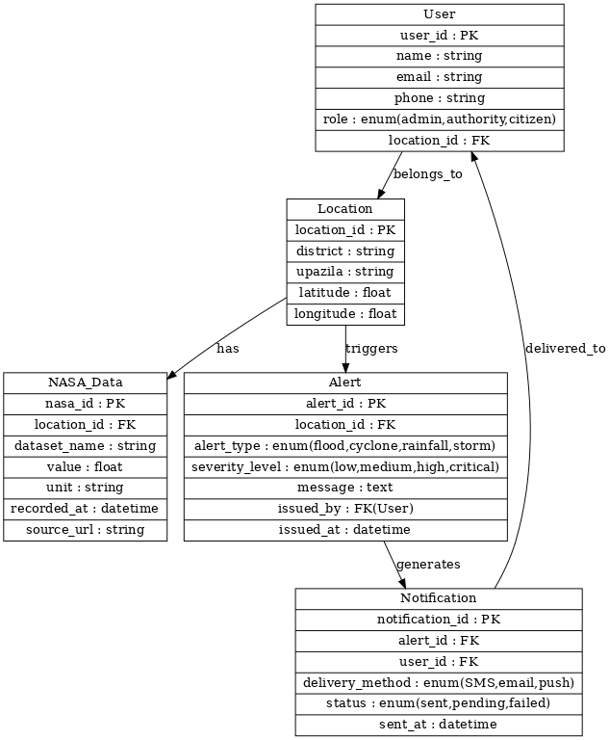

**2.3 USER CLASS and CHARACTERISTICS**

The disaster alert/early warning system will support **three types of users** with different privileges: **Citizens, Authorities, and Admins**.

### **1. Citizens (Customer role equivalent)**

* **Characteristics**: General population living in flood/cyclone/rainfall/storm-prone areas. They usually interact with the system through a mobile app, SMS alerts, or web portal.
* **Functions available**:  
  + Receive alerts about disasters in their location.
  + View latest weather/NASA data (e.g., rainfall, river level).
  + Subscribe/unsubscribe to alert notifications.
  + View history of alerts and personal notification log.
  + Confirm receipt of alerts (optional feedback).
  + Access safety guidelines and emergency contact information.

### **2. Authorities (Employee role equivalent)**

* **Characteristics**: Local government agencies, disaster management officials, and first responders responsible for monitoring and taking preventive measures. They have access to both citizen functions and additional monitoring/management tools.
* **Functions available**:  
  + **Citizen Functions** (as above).
  + View **all citizens** who are registered in a given location (to assess population impact).
  + Monitor **live NASA/environmental data** for specific locations.
  + View **active alerts** and their severity levels.
  + Get reports of **alerts delivered successfully/failed**.
  + Track the **status of notifications** (sent/pending/failed).
  + Generate summary reports of **disaster frequency and impact** for a given location.

### **3. Admins (Administrative role equivalent)**

* **Characteristics**: Central system operators and IT staff who manage the database, system configuration, and data feeds from NASA and other sources. They have full privileges.
* **Functions available**:  
  + **priority Functions** (as above).
  + Add/Delete a location (district/upazila).
  + Add new NASA dataset sources (e.g., rainfall, cyclone tracking).
  + Define/update **thresholds** for triggering alerts.
  + Add/Delete **alerts** manually (override).
  + Update **alert severity levels** or **messages**.
  + Add/Delete **users** (citizens, authorities).
  + Configure delivery methods (SMS gateway, email server, push service).
  + Monitor **system health** and ensure data consistency across sites.

## **2.4 OPERATING ENVIRONMENT**

The operating environment for the Flood & Cyclone Early Warning System is listed below:

* Distributed Database
* Client/Server System
* Operating System: Cross-Platform (Windows / Linux / macOS)
* Database: MongoDB (NoSQL, distributed database)
* Platform: MERN Stack (MongoDB, Express.js, React.js, Node.js)

## **2.5 DESIGN AND IMPLEMENTATION CONSTRAINTS**

* **Global Schema:** Unified schema with Users, Locations, NASA_Data, Alerts, and Notifications.
* **Fragmentation Schema:** Data fragmented by location/region for scalability.
* **Allocation Schema:** Fragments distributed across MongoDB clusters or shards.
* **Query Implementation:** Implemented using MongoDB queries (MQL).
* **Global Query Response:** NASA_Data aggregated across regions; Alerts combined with Users for targeted notifications.
* **Database Implementation:** MongoDB (NoSQL, distributed); can run centralized (local server) or distributed (cloud).

## **3. SYSTEM FEATURES**

### **3.1 DESCRIPTION and PRIORITY:**

The **Flood & Cyclone Early Warning System** maintains real-time information on weather data (from NASA datasets), alerts, and user notifications.

* **High Priority**: Timely and accurate alerts are critical to saving lives and preventing disaster-related damage in affected regions.

### **3.2 STIMULUS/RESPONSE SEQUENCES**

1. **User views alerts for their location**
   * **Stimulus**: User logs in or accesses the dashboard.
   * **Response**: Displays all active alerts relevant to the user’s location.
2. **System generates alert from NASA data**
   * **Stimulus**: New weather data indicates potential flood or cyclone.
   * **Response**: System creates an alert and sends notifications to all affected users.
3. **User subscribes to notifications**
   * **Stimulus**: User selects notification preferences (email, SMS, push).
   * **Response**: System delivers alerts based on the chosen communication channel.

### **3.3 FUNCTIONAL REQUIREMENTS**

#### **DISTRIBUTED DATABASE**

* The database stores NASA weather data, alerts, and user information in a **distributed manner**, allowing scalable access and processing.
* Data can be **sharded or replicated** across clusters based on location or dataset type for faster queries and high availability.

#### **3.4 CLIENT/SERVER SYSTEM**

* The system follows a **client/server architecture**:  
  + **Client**: React.js front-end interface for users to view alerts and notifications.
  + **Server**: Node.js + Express.js back-end handles API requests, processes NASA data, generates alerts, and communicates with MongoDB.
* All data resides on the **server side**, while the client executes the application interface.

## **4. EXTERNAL INTERFACE REQUIREMENTS**

### **4.1 USER INTERFACES**

* Front-end software: React.js (responsive web interface for users to view alerts and notifications).
* Back-end software: Node.js with Express.js (REST APIs for alert generation, user management, and data handling).

### 

### **4.2 HARDWARE INTERFACES**

* Operating system: Windows, Linux, or macOS.
* A browser that supports HTML5, CSS3, and JavaScript.

### **4.3 SOFTWARE INTERFACES**

|  |  |
| --- | --- |
| **Software used** | **Description** |
| Operating system | Cross-platform OS (Windows, Linux, macOS) for best compatibility and deployment flexibility. |
| Database | MongoDB (NoSQL) to store NASA datasets, alerts, and user information. |
| React.js | Front-end framework for building interactive user interfaces and real-time alert dashboards. |
| Node.js + Express.js | Backend runtime and framework to implement APIs, process data, and manage notifications. |

### **4.4 COMMUNICATION INTERFACES**

### The system supports all modern web browsers.

* The system is web-based and accessible through any modern web browser.
* Alerts and notifications are delivered via multiple channels such as **email, SMS, or push notifications**.

## **5. NONFUNCTIONAL REQUIREMENTS**

### **5.1 PERFORMANCE REQUIREMENTS**

* The system should fetch and process NASA weather data efficiently to generate timely alerts.
* Alerts must be delivered to users within seconds after being issued.
* The application should handle multiple users simultaneously without performance degradation.
* The database should support fast read/write operations for storing and retrieving user, location, and alert data.
* The web interface should be responsive on both desktop and mobile browsers.

### **5.2 NORMALIZATION**

* The database is designed to reduce redundancy by storing each piece of information only once.
* Tables are broken into smaller, thematic tables (Users, Locations, NASA_Data, Alerts, Notifications) to avoid modification anomalies.
* The database is normalized up to **3NF**, which is sufficient for preventing insertion, update, and deletion anomalies while maintaining performance.

### **5.3 SAFETY REQUIREMENTS**

* Regular database backups will be maintained to prevent data loss from hardware failures or catastrophic events.
* In case of a failure, the database can be restored from backups and any committed operations can be reapplied from transaction logs to recover the most recent state.

### **5.4 SECURITY REQUIREMENTS**

* User authentication and role-based access control will secure sensitive operations (e.g., issuing alerts).
* Data transmission between front-end and back-end will be encrypted (HTTPS).
* Notification data and user information will be stored securely in the database with proper access restrictions.

### **5.5 SOFTWARE QUALITY ATTRIBUTES**

* **Availability:** Alerts should be available and delivered in real-time to users during extreme weather events.
* **Correctness:** Alerts should accurately reflect the location, type, and severity of floods or cyclones.
* **Maintainability:** The system should support regular updates for backend logic, front-end UI, bug fixes, and security patches.
* **Usability:** The application should be user-friendly and accessible on multiple devices, including desktops and mobile browsers.